[BCIS 5610 Enterprise Data Warehousing (Fall 2020)](https://unt.instructure.com/courses/32520)

Assignment -1

**Teachers Pay Teachers** is an online marketplace for teachers that connects teachers across the globe. This platform allows teachers to buy, sell, or share their educational materials with other teachers.

I have created a database named ‘tpt’. There are 10 entities that are interlinked. These 10 entities later become 10 tables (or Relations).

Please find the snapshots of MySQL database named ‘tpt’ that I created and the 10 tables that are inside this database. The names of all the tables are as follows:

1. Buyer_anannyac
2. Seller_anannyac
3. Product_anannyac
4. Cart_anannyac
5. Cart_item_anannyac
6. Order_anannyac
7. Order_item_anannyac
8. Transaction_anannyac
9. Review_anannyac
10. Wishlist_anannyac

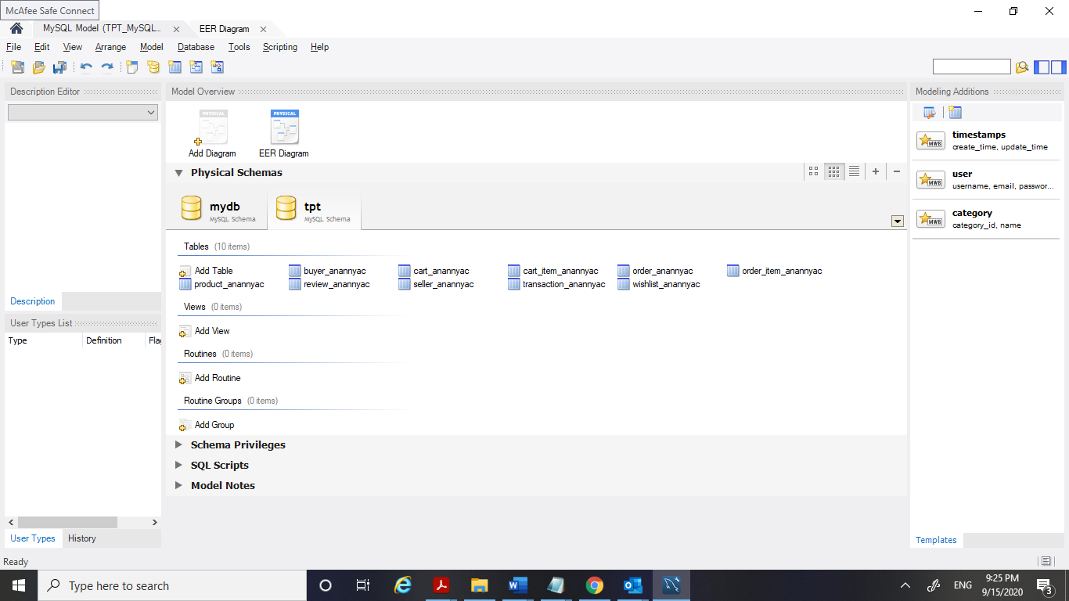

1. **Buyer_anannyac**

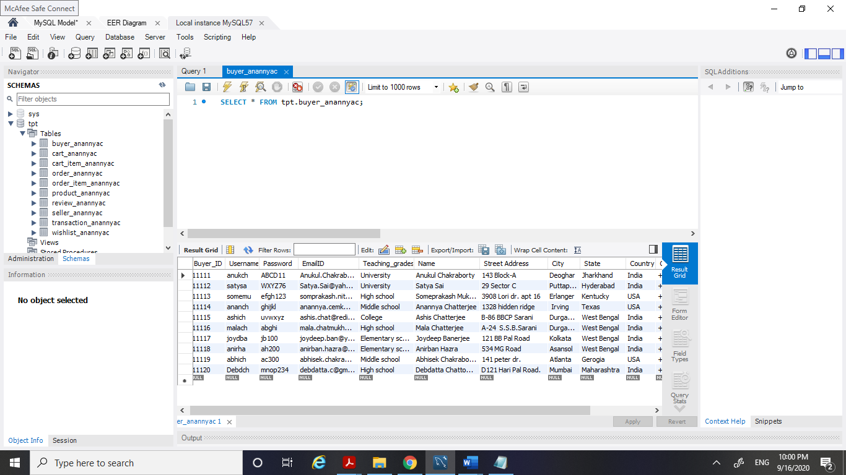

1. **Seller_anannyac**

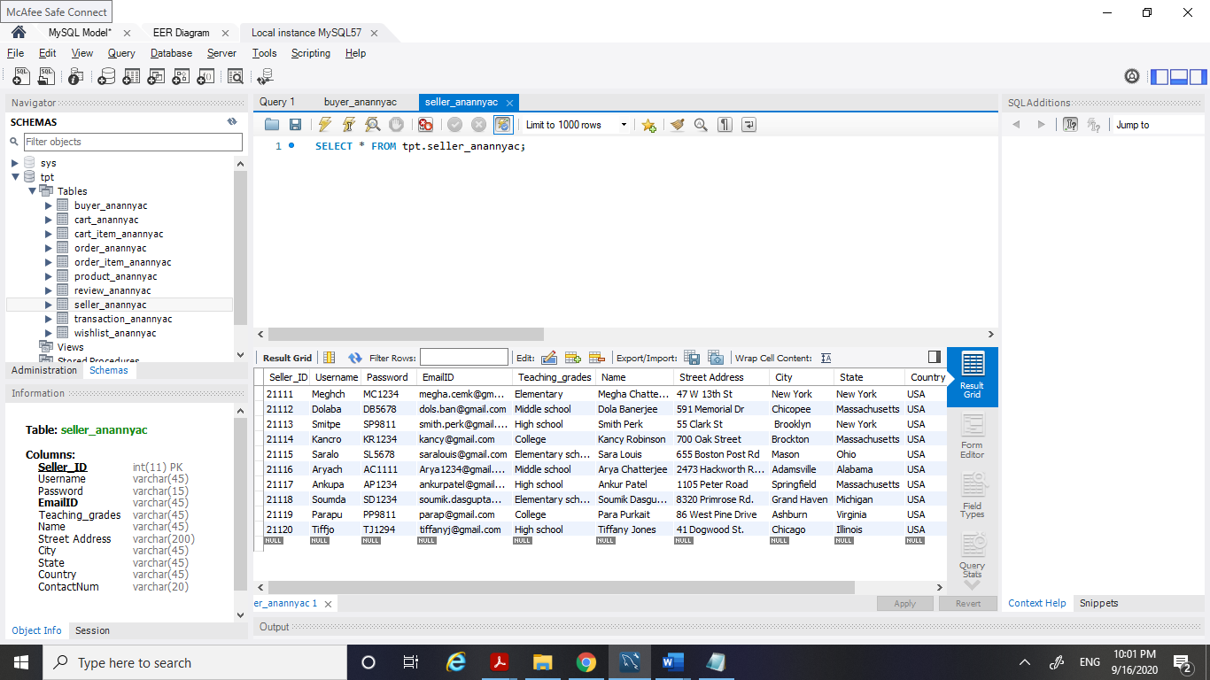

1. **Product_anannyac**

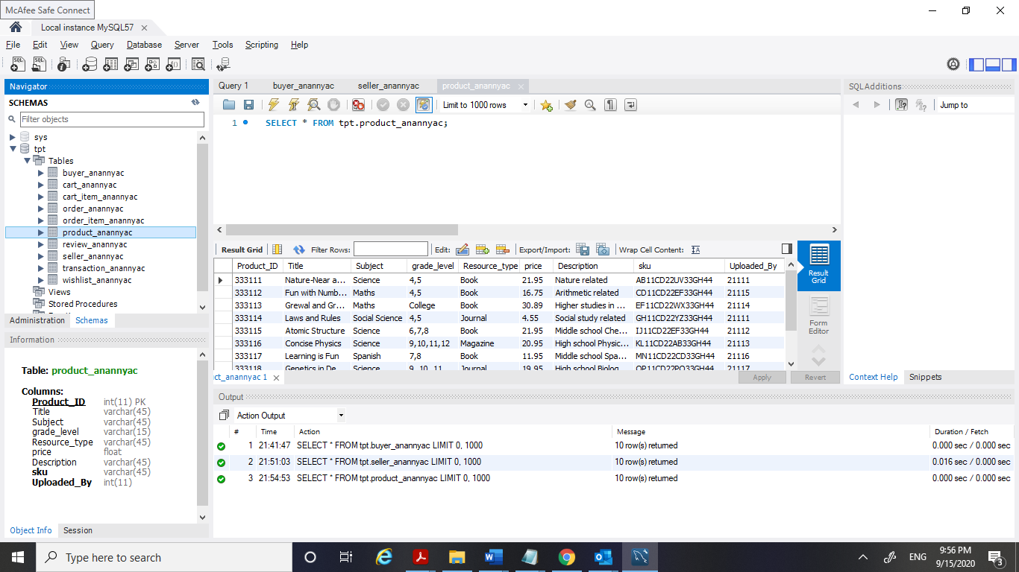

1. **Cart_anannyac**

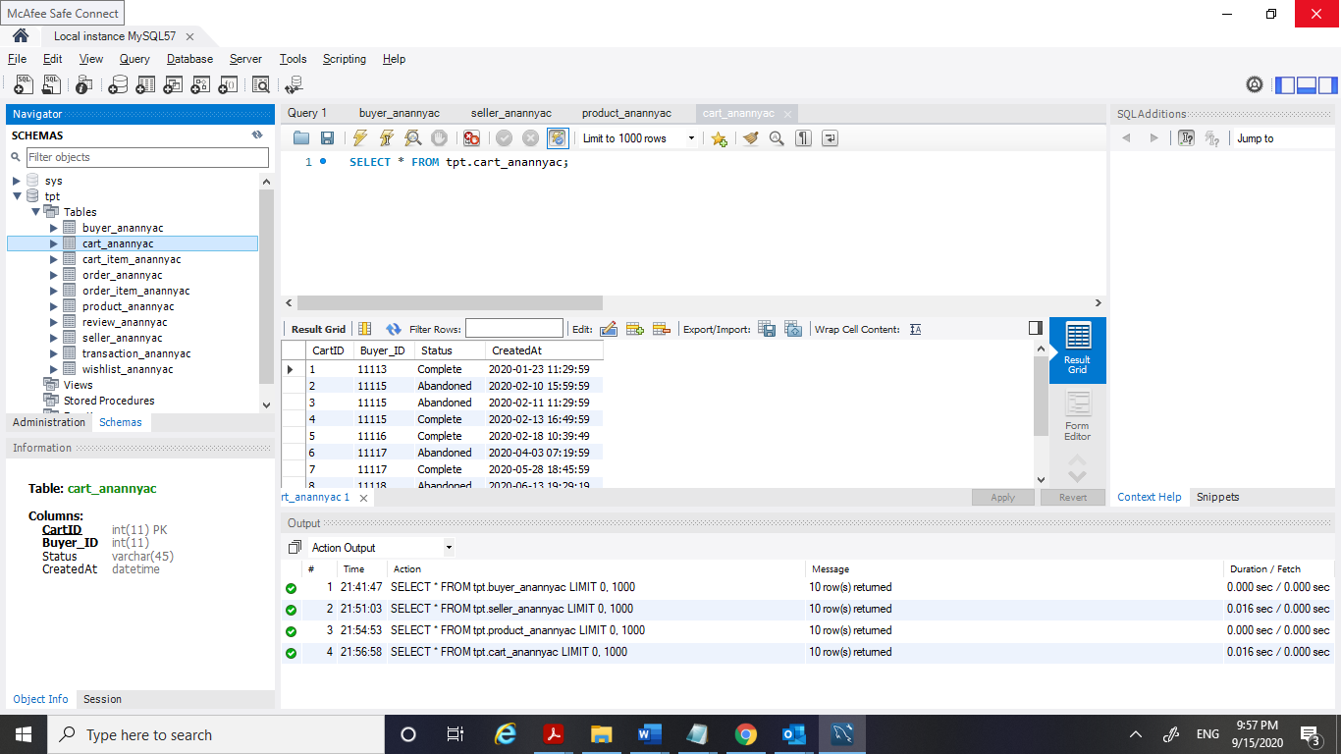

1. **Cart_item_anannyac**

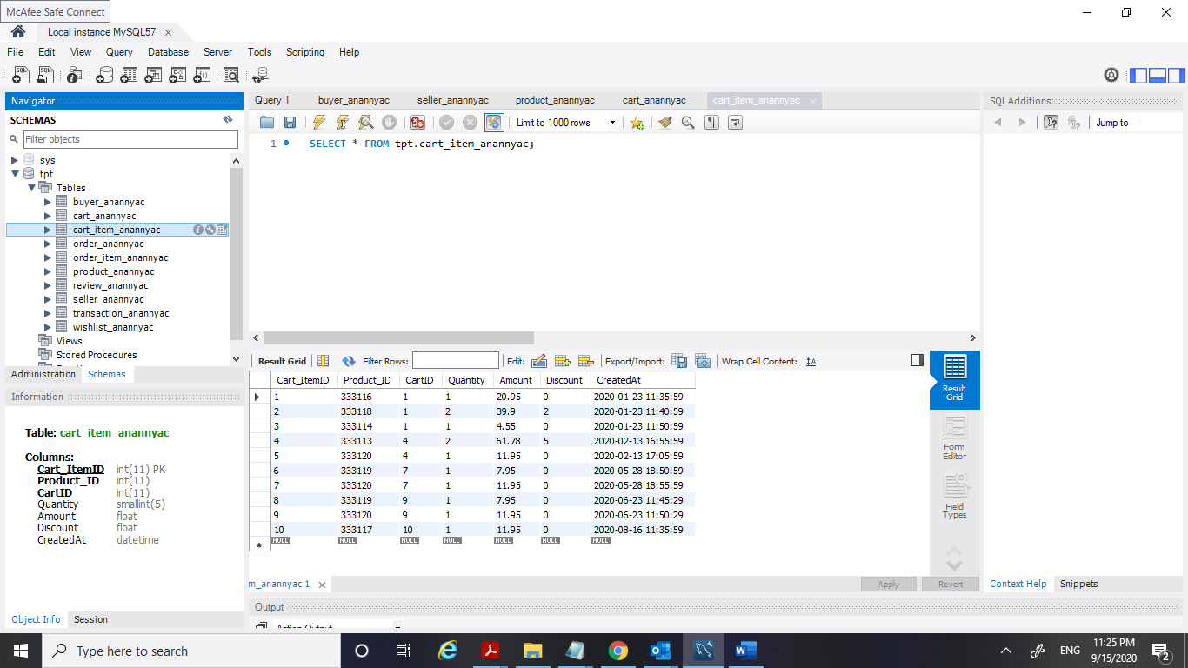

1. **Order_anannyac**

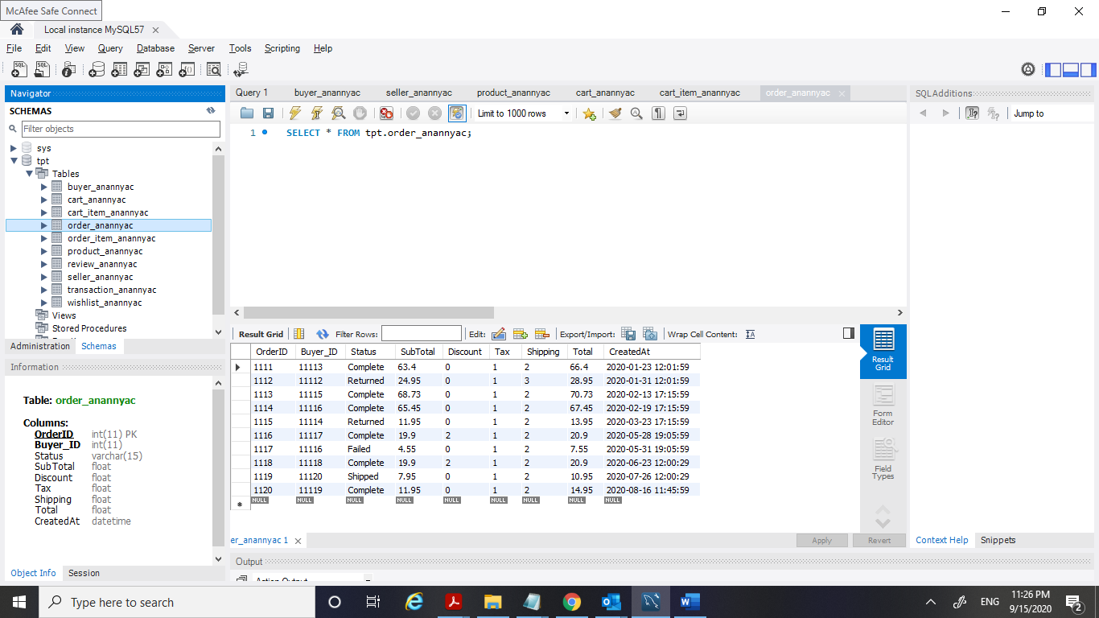

1. **Order_item_anannyac**

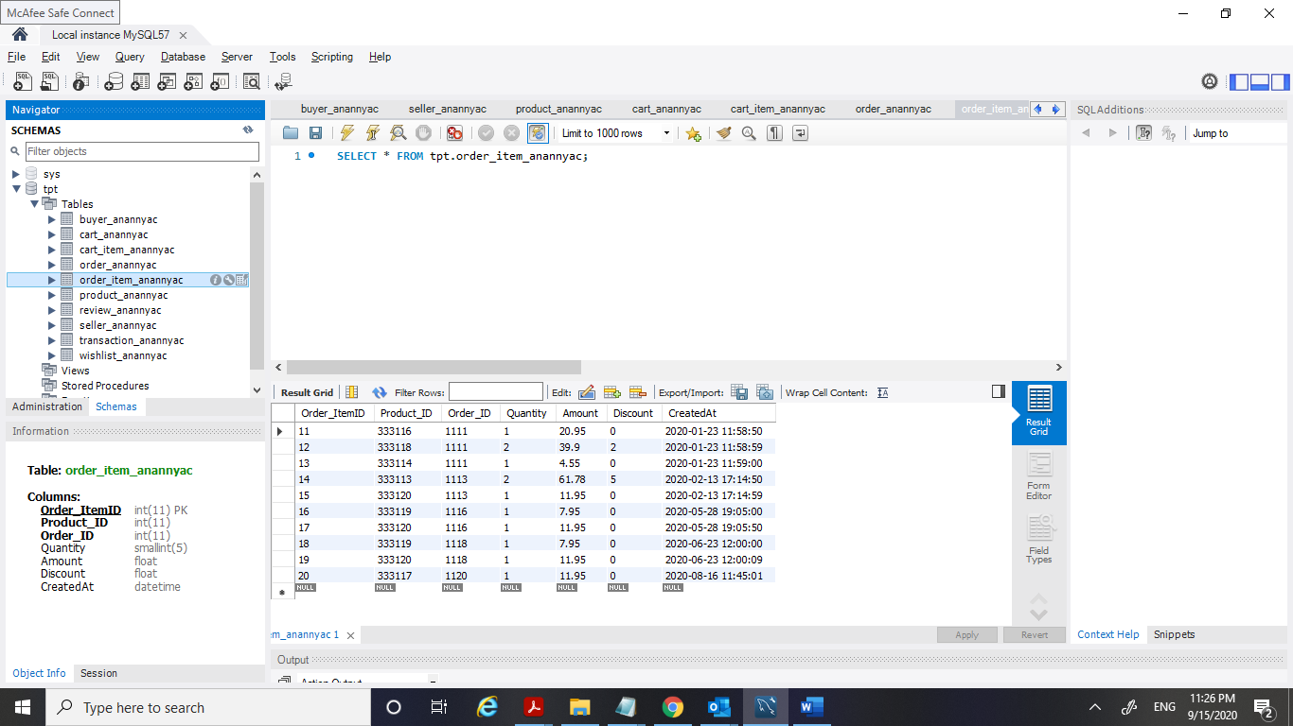

1. **Transaction_anannyac**

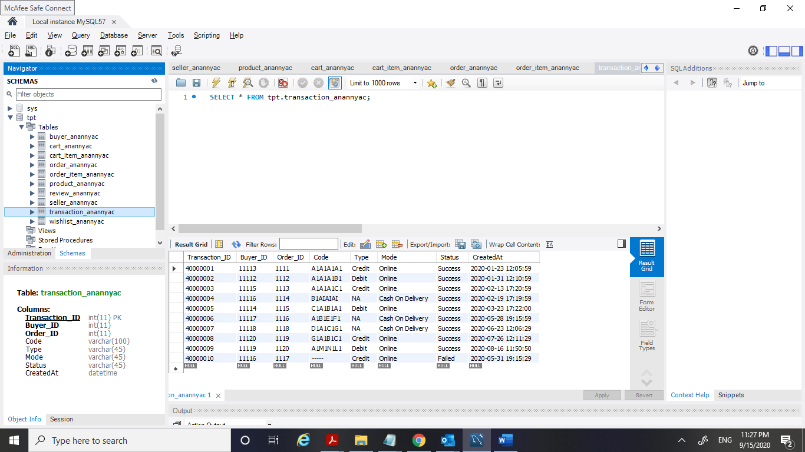

1. **Review_anannyac**

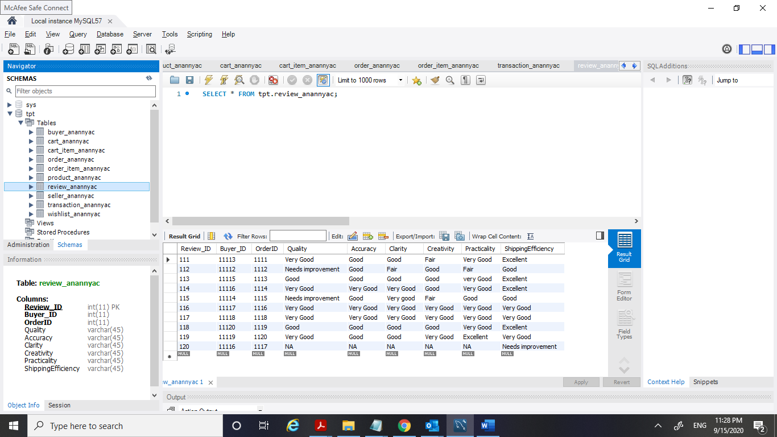

1. **Wishlist_anannyac**

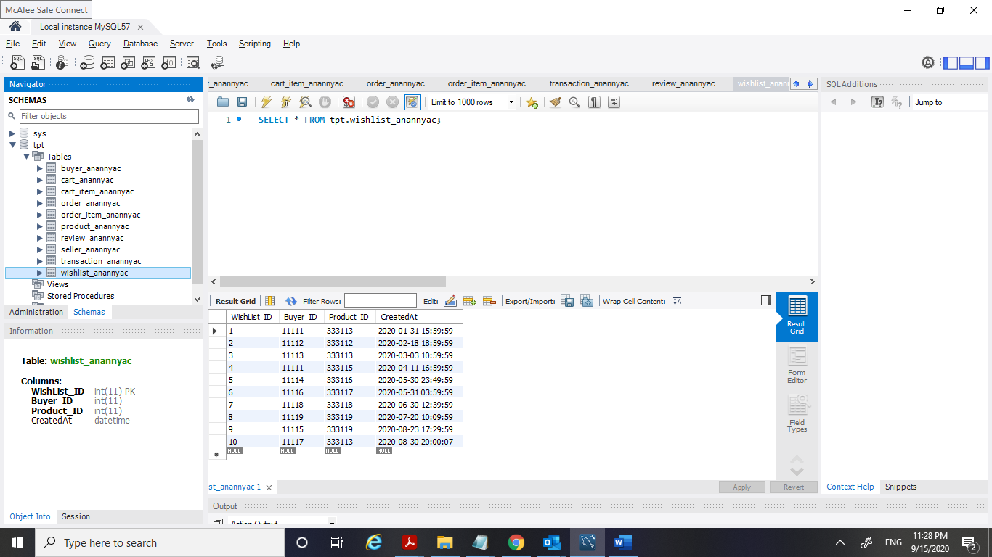

**Relationships between the entities:**

1. One SELLER can Upload many PRODUCTs.  **Minimum Cardinality = 1**

One PRODUCT is Uploaded by only one SELLER**. Minimum Cardinality = 1**

1. One BUYER Buys many PRODUCTs **Minimum Cardinality = 1**

One PRODUCT may be bought by Many BUYERs **Minimum Cardinality = 0**

1. One BUYER can get MANY CART **Minimum Cardinality = 1**

One CART is assigned to only ONE BUYER **Minimum Cardinality = 1**

1. One CART contains Many CART_ITEM **Minimum Cardinality = 1**

One CART_ITEM is contained in only ONE CART **Minimum Cardinality = 1**

1. One BUYER may Add/delete 0 to Many CART_ITEM **Minimum Cardinality = 0**
2. Each CART_ITEM is added/deleted by only 1 BUYER **Minimum Cardinality = 1**
3. One BUYER may place Many ORDER **Minimum Cardinality = 0**

One ORDER is placed by only ONE BUYER **Minimum Cardinality = 1**

1. One ORDER contains many ORDER_ITEM **Minimum Cardinality = 1**

One ORDER_ITEM is contained in only 1 ORDER. **Minimum Cardinality = 1**

1. One BUYER may transact Many ORDER **Minimum Cardinality = 0**

One ORDER is transacted by only one BUYER. **Minimum Cardinality = 1**

1. One BUYER may provide Many REVIEW **Minimum Cardinality = 0**

One REVIEW is provided by only ONE BUYER. **Minimum Cardinality = 1**

1. One BUYER May create 0 to Many WISHLIST **Minimum Cardinality = 0**

One WISHLIST is created by only One BUYER **Minimum Cardinality = 1**

-------------------------------------------XXXXXXXXXX---------------------------------------------